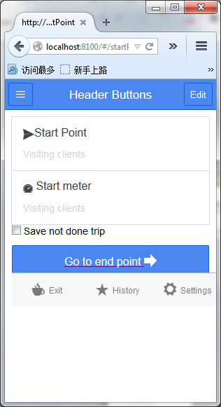

<div class="bar bar-header bar-positive">

<button class="button icon ion-navicon"></button>

<h1 class="title">Header Buttons</h1>

<button class="button">Edit</button>

</div>

<ion-view>

<ion-content has-tabs="true" padding="true">

<form >

=====================================================================

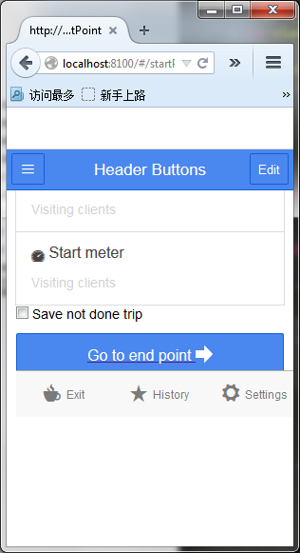

<ion-view>

<ion-content has-tabs="true" padding="true">

<div class="bar bar-header bar-positive">

<button class="button icon ion-navicon"></button>

<h1 class="title">Header Buttons</h1>

<button class="button">Edit</button>

</div>

<form >

<div class="list">

<a href="#/endPoint">

<div class="item item-button-right">

Go to end point

<button class="button button-dark">

<i class="icon ion-ios7-telephone"></i>

</button>

</div>

</a>

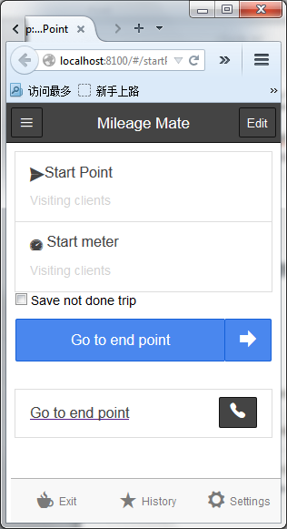

<div class="item item-button-right">

<a href="#/endPoint">

Next

</a>

<a href="#/endPoint">>>>>>>>>>>LINK CAN’T PUT BEFORE BUTTON

<button class="button button-dark" ng-model='button' ng-disabled='notDone' ng-click='saveNewTrip()'>

<i class="icon ion-android-folder"></i>

</button>

</a>

</div>

